

RS

GH#390 – Correct Verbiage of Rollback Language on Competitive Bid Amount Message

Julie Felberg | February 20, 2015

|  |  |  |  |
| --- | --- | --- | --- |
| Category | Config | Sub Category | Config - Rules |
| Use Case |  | Test Case |  |
| LOE |  | Go Live Date |  |

# Business Reason

## Competitive Bid Amount language is not consistent. Please add to GitHub as a bug, just a verbiage issue. Red Text should note “Rollback of Current Rate(s)” as opposed to “Rollback of Current Price”. Verbiage should be constant.

# Task Requirements

1. Change the constraint message on Competitive Bid Amount so it reads “Rollback of Current Rate(s)” and not “Rollback of Current Price.”

# Build Plan

1. Edit the Competitive Bid is required config, constraint rule.
   1. All Product Families 🡪 Republic Services Family 🡪 Containers Product Line 🡪 Service Change Model 🡪 List constraint rules
2. Change the text of the error message

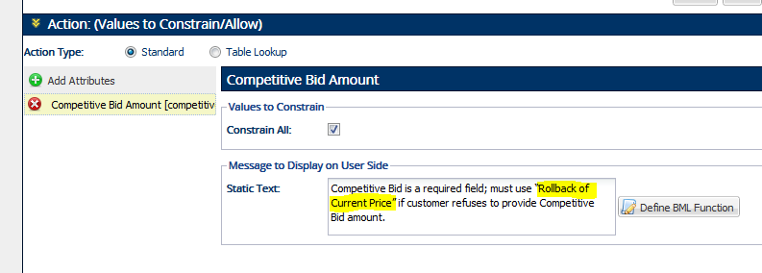

1. Save the rule
2. Deploy the Republic Services Config Family
3. Unit Test (in dev)
   1. Ask Aaron for an account number
   2. Create a new quote for an existing customer
   3. Do a Service Change with the following choices

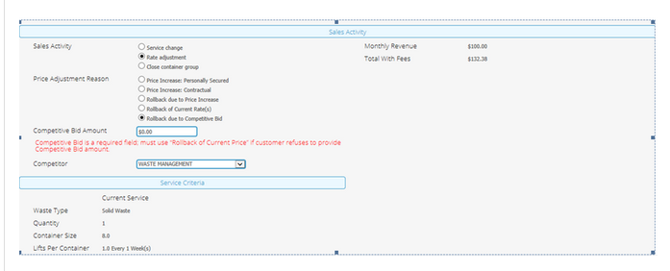

* 1. Confirm constraint message pops up and has the new, corrected verbiage.
  2. POST THE UNIT TEST TO GITHUB (with screenshots and quote numbers)

# Implementation Profile Changes

None.

# User Guide Changes

## None.